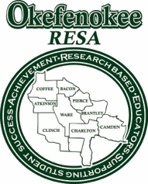
Okefenokee RESA GaTAPP Application Cover Sheet – 2024 Cohort

Use this sheet to check off all required pieces of the GaTAPP application. Incomplete application packets will not be processed.

_____ $50.00 application fee (check or money order), non-refundable

_____ Copy of your transcripts from all colleges and universities attended. Copies must be readable.

_____ Demonstration of Content Knowledge: See document “Demonstration of Content Knowledge Options for Program
Admission” to determine your options. Select the option you are using for admission below:

a.) GACE assessment: Include a COPY of the GACE passing score report. The score report must show your
score on each part of the assessment. Please select Okefenokee RESA as your program provider when
taking the assessment.

b.) Degree option: No additional submissions required

c.) Coursework option: No additional submissions required.

_____ COPY of Georgia Educator Ethics GACE (Test 360) certificate. Please select Okefenokee RESA as your
program provider.

_____ Administrator Assurance Form – Signed by your Administrator (Principal)

_____ System Assurance Form – Signed by your system HR person

_____ Candidate Assurance Form – Signed by you

_____ Complete Application

All GaTAPP application packets should be sent to:
Okefenokee RESA
1450 N. Augusta Ave.
Waycross, GA 31501
Attn. Jennifer Hale

If you have questions on the admissions requirements, please contact:

Rhonda Gatewood, GaTAPP Coordinator
rgatewood@okresa.org

