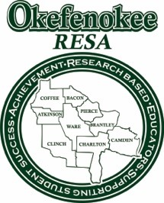
1450 North Augusta Avenue · Waycross, Georgia 31503 · (912) 285-6151 · Fax (912) 287-6650
http://www.okresa.org

Dr. Greg Jacobs
Executive Director

Photo and Video Opt-Out Release Form

I do not authorize Okefenokee RESA, its employees, or volunteers, to record photographs or other images or likenesses of me in the form of videotape, audiotape, film, digital stills, or any other medium. I do not authorize Okefenokee RESA to use, reproduce, modify, distribute, or publicly exhibit such recordings, in whole or in part, for any purpose.

____ I understand it is my responsibility to remove myself from areas being videotaped or photographed and to notify the photographer of my opt-out status.

____ I hereby confirm that I am legally of full age (18) and have every right to contract in my own name as stated above. I further affirm that I have read the above “Photo Opt Out Release,” and am familiar with its contents.

Date:________________________

Participant Name:________________________________
Participant Signature:________________________________

